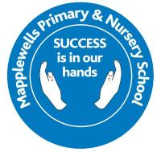
F1 Newsletter

Welcome  Dear Parents/Carers,  We hope you had a fantastic Summer break and were able to spend quality time with your families. We are really looking forward to starting our new academic year with our fantastic children and hope that you are too!  For those of you that are new to Mapplewells, we would like to take this opportunity to welcome you and we hope that you are beginning to find your feet and settle in. There is lots of information in this newsletter which we feel may be useful and answer your questions. Over the coming weeks you may have questions about the routines of our class or how you can support your child at home. Please do not hesitate to speak to a member of the Foundation team should you have any questions. In Foundation 1, the teacher is Miss Spurr and our Teaching Assistant is Mrs Smith. We hope that you enjoy your year in F1; we are really looking forward to it.  This is the start of your child’s future, so let’s work together to make it a brilliant one. It is going to be an extremely busy but exciting term and we cannot wait to get started!  Curriculum Enquiry  Each term we focus our learning around an enquiry question based on a whole school driver. This term our driver is ‘Understanding the world- History’ and our curriculum enquiry question is ‘Are celebrations always positive?’ Children will be learning about different celebrations and the history of how they started, for example, why people celebrate bonfire night and the origins of how this event came about. We will also be learning about celebrations from different cultures through our enhancer subject ‘Understanding the world– RE’.  Children will use what they have learnt to produce dioramas of their findings, which will then be presented to a special visitor at the end of term, who will discuss the findings with the class.  During the Autumn term, we will be reading a variety of stories linked to the enquiry and the provision will be set up to enhance and support the children’s learning.  Physical Education    PE sessions are on Tuesday mornings and Friday afternoons. If your child has their ears pierced, can you please ensure that on PE days their earrings are taken out before school and that no jewellery is worn. It is part of our Uniform Policy that every child at Mapplewells wears the correct PE kit.  Our PE Kit:  - White short sleeved polo shirt  - Royal blue shorts  - Plain black/grey/white socks  - Plain trainers (outdoor) or plimsolls (indoors)  - A plain tracksuit in keeping with school colours of blue, grey or black  Forest School  - We are delighted to offer our foundation children the opportunity to attend our on-site Forest School. Our sessions are led by Miss Christie who is Forest School qualified.  - In your welcome packs you should have received a permission form for Forest School, please ensure this is returned to school as soon as possible if it hasn’t been done so already. If you require a new form please let a member of Foundation or the office know.  - Forest School will take place on Wednesday afternoons (dates below). On these days the children will need to come to school dressed in their Forest School clothes. Your child will be provided with waterproof clothing from school, however please feel free to provide your child with their own waterproof clothing if you wish.  - We will be attending Forest School whatever the weather (unless dangerous) and we will not be held responsible for the damage of any clothes during the sessions, so please be aware your child’s clothing may return home damaged or muddy.  The correct clothing is listed below:  - Warm trousers  - Thick socks  - A long sleeved top (no t-shirts or short sleeves)  - Wellies or walking boots (named, to stay in school)  - A hat (when appropriate)  - A pair of gloves (when appropriate)  - A scarf (when appropriate)  Please see below the dates for the Forest School sessions for the Autumn term:  - 23rd, 30th September  - 7th October  - 11th, 18th, 25th November    Wow Cards  Each half term you will be given a set of ‘WOW cards’. These are for you to celebrate your child’s achievements outside of school. Please send them into school so that they can be shared with their peers and the cards can be displayed on our ‘WOW’ display. Reasons to celebrate your child may include sleeping in their own bed all night, using their knife and fork correctly, using their manners or swimming a length etc.  Outdoor Equipment: For safety reasons, please make sure your children are not playing on the equipment in the Foundation Unit playground before and after sessions and with the activities set out. | Reading    We encourage you to read with your child every day at home. For each read that your child completes and is written in their reading diary, your child will contribute towards the total class reads, when we reach 250 reads, we will have a class treat.  Children will bring home a book to share and love. Our children will choose this book from their class reading area. The children might have heard it lots in class so can take it home to retell or it’s a book that someone at home can read to them.  Children will also bring home 2 independent books, these may not have any words in, it is for them to get used to holding a book, the parts of the book and telling a story using the pictures. If your child has a book with words you can encourage them to say the codes that they can see and help them to blend the words.  Fruit, Milk and Snacks  Every day the children will have the opportunity to have fruit in the morning and milk in the afternoon. All children are allowed 1 piece of fruit per day. If you wish for your child to have milk, please sign up via the Cool Milk website. If you wish to send your child in with a snack from home that is absolutely fine- please just make sure this is healthy, such as some mini breadsticks or a cereal bar.  Belongings  Please ensure ALL your child’s things have their name on, as I’m sure you can imagine how difficult it is if items are not clearly named. If something does go missing, please report this to a member of the Foundation Staff straight away. It is easier to find things if we know immediately when names are written on or sewed into the tag. We do encourage the children to take responsibility for their own items and we ask that you too take this approach.  Coming into school  Remember, the gate will be opened for the morning session at 8.30am and these children are collected at 11.30am. The gate will be opened for the afternoon session at 12.30pm and the children are collected between 3:15pm and 3:30pm during our soft close. If you are late to school, please report to the school office so that your child can get their mark. Just a polite reminder to please remain outside when dropping your child at school. We would like the children to come into the classroom independently and find their peg etc. We understand it can sometimes be a tricky transition for some children but a familiar adult will be in the classroom to support them so please try not to worry. If you will be collecting your child early, please let the office know in advance to allow us to get your child ready as when we are not expecting someone to go home it can cause interruption to our learning time. Thank you.  Bringing Toys to Nursery: We completely understand that some children like to bring a toy as a comfort, however we do not want any toys being lost or broken. We ask that the only belongings being brought into school are their water bottles, coats, reading bags and a spare set of clothes and wipes.  When Collecting Your Child: When collecting your child, they will wait with an adult until they are called, please wait on the playground for your child. If you need to speak to a member of staff, please hang around until all of the children have been dismissed and someone will be happy to have a chat with you. If a member of staff needs to share any information with you, they may ask you to wait until the end so that they can have a more private discussion with you.  Contributions  We love to get creative in EYFS and use all our senses to explore. We always try to plan exciting learning opportunities for the children to enjoy. Some of these activities require us to use lots of resources. If you would like to make a voluntary donation towards these consumables of £2 each half term it would be greatly appreciated. Alternatively, if you wish to donate resources to support us that would also be extremely appreciated. Helpful items include:  - Flour & salt (playdough)  - Colouring pencils  - Gel pens  - Notebooks  - Paint  - Food colouring  - Envelopes  - Marbles/smooth glass pebbles  - Corks  - Dry beans  - Cardboard tubes  - Glitter  - Wooden logs  - Wooden pegs  - Bottle tops  - Dry pasta  - Rice  - Conkers  - Pine cones  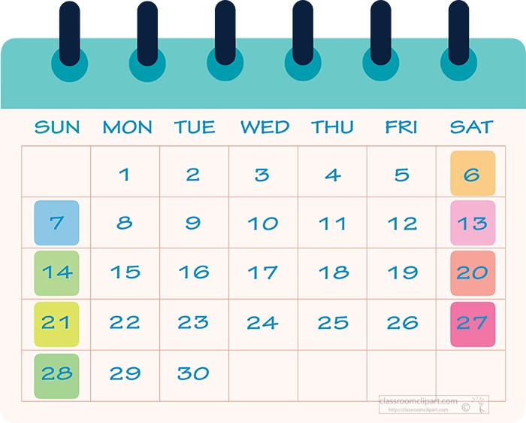  Key Dates  - Welcome to Mapplewells Party-Tuesday 15th September- PM.  - Foundation Diwali Dance Workshop-Thursday 12th November.  - Harvest Festival Week-W/C 5th October.  - Autumn Disco-TBC  - Friday 16th October-Last day of Autumn 1  - Monday 2nd November-First Day of Autumn 2  - Christmas performance-Thursday 10th December at 10am and 4pm.  - Christmas Fair-TBC  - Friday 18th December-Last day of Autumn 2  I would like to take this opportunity to thank you all in advance for your support and express how much we are really looking forward to beginning your child’s new journey together.  Miss Spurr & Mrs. Smith

