Who is significant?
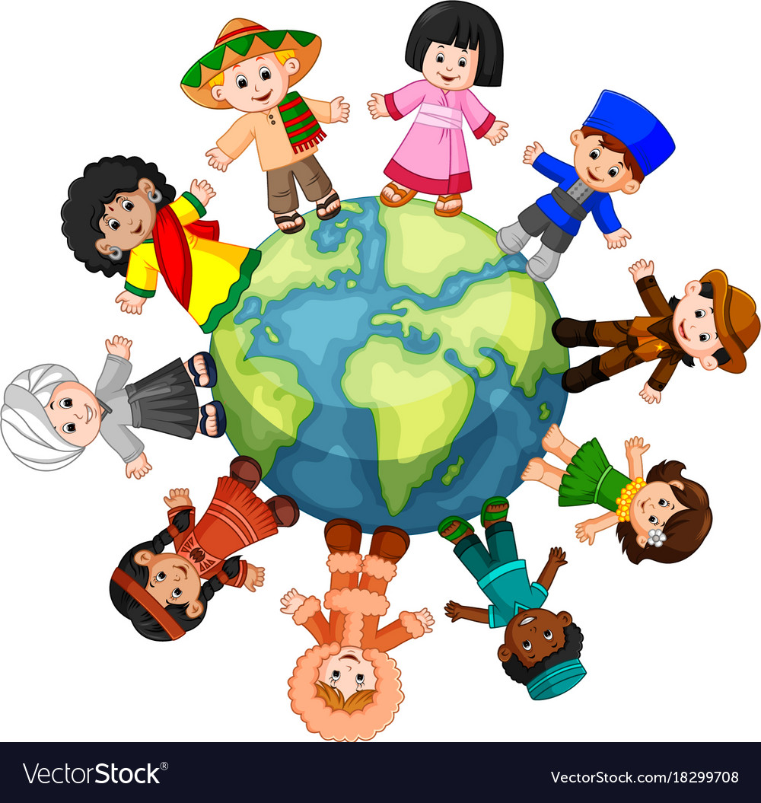
Autumn 2025

