
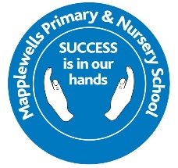
What benefits will my child get from participating in Forest School?
Forest School supports the holistic development of the child:
- Health and fitness – Being active in an outdoor, natural environment.
- Increased emotional wellbeing – There is research available supporting this.
- Social development – Communicating, and negotiating with peers and adults to solve problems and share experiences.
- Skills development – Developing fine and gross motor skills and coordination for real purposes.
- Gaining knowledge and understanding – Multi–sensory, real-life learning.
- Individualised learning – Careful observation allows adults to tailor support to children’s own interests and stage of development.
- Curriculum Links – Forest School supports many areas of the Early Years Foundation Stage framework, National Curriculum and the Every Child Matters agenda.

Parent Guide
Forest School

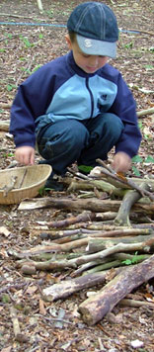
Health and Safety
The health and safety of all participants is central to everything done within our Forest School programme. The Forest School training leaders are fully trained in risk assessment and emergency first aid. Forest School will always have; a Health and Safety policy; a seasonally and daily risk assessed site; risk assessments for activities; trained adult helpers; first aid and emergency equipment. Some of the activities the children may participate in are ‘higher-risk activities’ (such as campfire cooking or tool use). However, these activities are not available to the children until certain behaviours and boundaries are established. Children are encouraged and supported in recognising and managing risk for themselves, through real life situations and experiences.
Your child will need to be dressed appropriately for the weather, warm clothes and wellies during winter months and comfortable long sleeved and long trousers during summer months. (Spare socks are recommended)

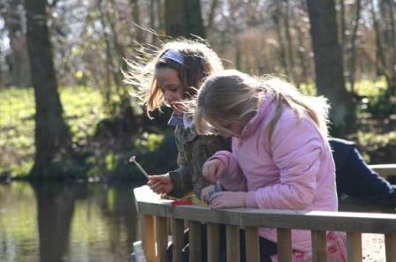

“This is the best kind of classroom,
It’s a journey through time and space,
From the smallest seed to the largest tree,
This is a Forest and a learning place.
This is the best kind of classroom,
Where the seasons don’t happen in books.
Where the learning is watching and thinking and talking
And everyone notices, everyone looks.”
From ‘The best Kind of Classroom’ by Ian MacMillan

If you have any further questions please feel free to come in and see me
Miss Christie
Forest School Leader.
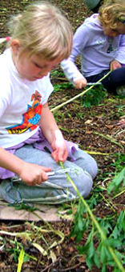
What will my child be doing?
The Forest School routine includes; preparing to go out by dressing in outdoor clothes such as waterproofs; (which we provide, please feel free to send your child in waterproofs if they have some) walking up to the site; singing special songs and sharing stories. Forest School will run all year round and in all weathers (unless weather conditions are dangerous). The child led ethos of Forest School means that once at the site the children can choose what to participate in, carefully supported and encouraged by trained adults. Possible activities may include:

- Hunting for mini beasts and
- Natural crafts – making necklaces from elder, crowns or dream catchers from willow, collages from natural materials, weaving with long grasses, tree cookies, etc

What is Forests School?
Forest School has developed from the Scandinavian education system and is about children and young people building self esteem and independence through exploring and experiencing the natural world. Forest School is a long term programme delivered by a trained practitioner within a natural environment (not necessarily a Forest!). Our Forest School programme is tailored to meet the needs of individuals within that group and is continuously developed as the children grow in confidence, skills and understanding.
The ethos of Forest School allows learners the time and space to develop skills, interests and understanding through practical, hands-on experiences. It also allows practitioners to step back and observe the children in order to then encourage and inspire individuals to achieve through careful scaffolding and facilitating.

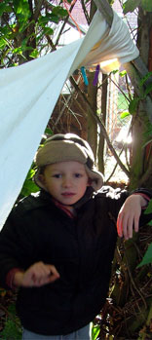
- Mud sculptures
- Shelter building
- Tree climbing
- Using tools for a purpose – such as peeling bark from sticks to make toasting forks.
- Fire building and cooking on a camp fire (Summer months)

Sessions are planned around the individual’s and group’s needs, and built upon each week. Our Forest School Leader has worked towards a nationally recognised and accredited level 3 qualification, therefore ensuring Forest School is a high quality learning experience. The earlier sessions will concentrate on safety; establishing boundaries and routines. As the children develop in confidence and familiarity with the environment the sessions focus on the development and consolidation of skills and understanding.

“Forest School is an inspirational process that offers children and young people opportunities to achieve, develop confidence and self esteem, through hands on learning experiences in a local woodland environment.”
National definition: by Forest School (England) Network

Where will my child be going?
Our Forest School site is in the corner of the school field. It has a designated ‘base camp’ that all the children can gather around. There are sticks, logs, leaves and trees. The site has been thoroughly risk assessed and managed appropriately by a trained practitioner.

