Mapplewells
Primary & Nursery School
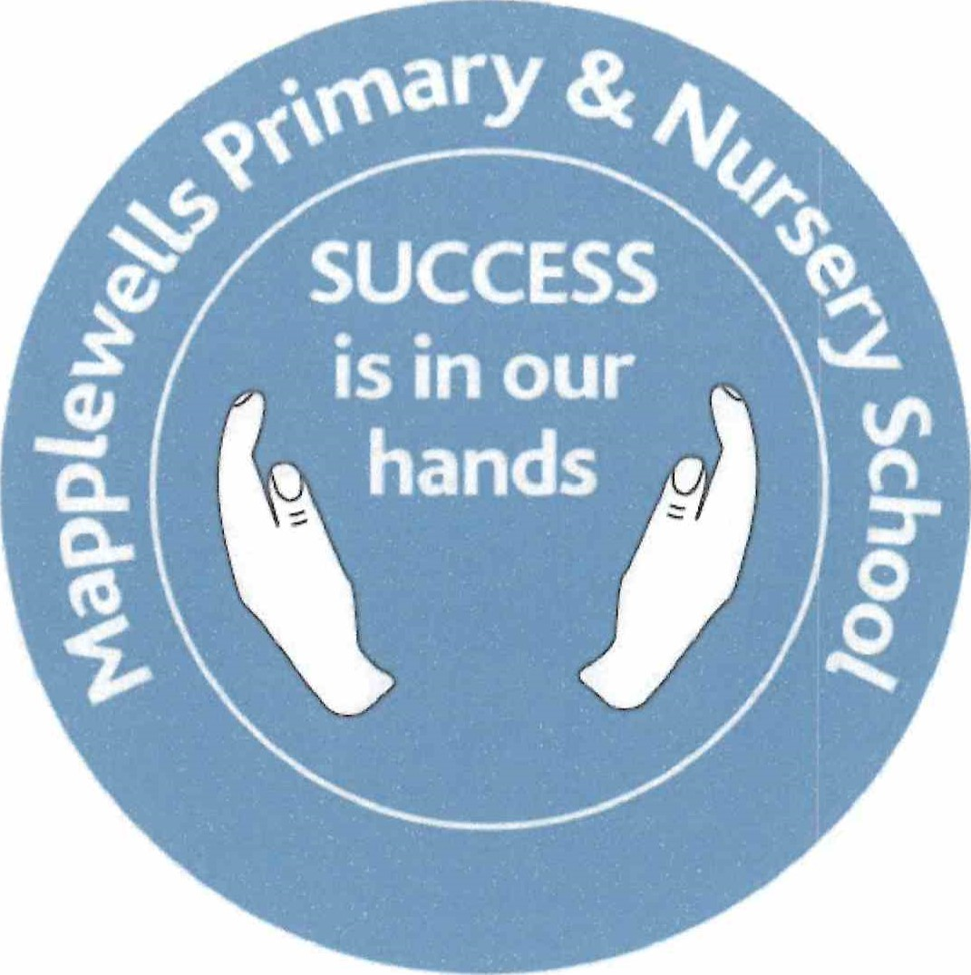

PE Policy
Reviewed and updated September 2024
Introduction:
The Physical Education Policy reflects the consensus of opinion of the whole staff and has been drawn up in consultation with staff and governors.
The school aims and mission statement underpin all that we do in school:

School aims
- To provide an environment in which all children feel safe, cared for and supported.
- To encourage independence and confidence to take risks and make their own decisions
- That every child who walks out of the door at the end of Year 6 will have become the very best that they can be

All our aims are encapsulated by our motto SUCCESS:
S - self-confidence
U - understanding
C - celebration
C - curiosity
E - excellence, enthusiasm and enjoyment
S - self-discipline
S - support

Vision statement
To provide every child in our care with the best quality education possible, in a warm, respectful and caring environment. Our children will be capable of dealing with the priorities of today as well as the unknown priorities of tomorrow. To put our school in the heart of the community and form links with that community which will benefit our children.
The implementation of this policy is the responsibility of all staff and has been written in accordance with the equality policy.

Aims
The aims of the policy are:
- To deliver Physical Education to children in the Foundation Stage through the Early Years Foundation Stage curriculum,
- To deliver National Curriculum PE to children in Key Stage 1 and 2
- To enable children to make progress and develop their knowledge, understanding and skills as they progress from the Foundation Stage to Key Stage One and Two.

In developing this policy we have discussed and incorporated the five outcomes from 'Every Child Matters'
Be healthy
All children have the opportunity to look at the importance of being fit and healthy and all the benefits that come with it. We provide opportunities for comparing the lifestyles of people and discuss how our actions and lifestyle choices can have an important impact on our health.
Stay safe
We will ensure that all children in school are aware of safety when participating in any form of physical activity.
Enjoy and achieve
We will ensure that all our pupils have the opportunity to achieve their full potential in all lessons. The teaching of PE will incorporate a variety of learning styles. There will be lots of opportunities to learn in different ways and use cross curricular themes to make PE relevant and fun. Children will be aware of their learning goals at the beginning of each lesson and they will be given feedback to help them develop their learning. Pupils' work will be valued and celebrated in a variety of ways.
Make a positive contribution
We will give all our pupils the opportunity to contribute their ideas and skills by working alone, in pairs and in groups/teams. We will encourage pupils to perform, observe and support each other throughout PE lessons. Cross curricular work will include applying mathematical skills in games, problem solving and teamwork.
Achieve economic well-being
The skills learned by our pupils will help to prepare them to achieve success and economic well-being in later life.

Planning
In the foundation Stage, Curriculum Enquiry questions are planned as a team around the Early Years Foundation Stage curriculum and Trust Key Knowledge Progression Documents (KKPD’s) with PE being covered in 'Physical Development'. In Key Stages One and Two team planning takes place termly and planning is based on a two yearly cycle.
All teachers use ‘Complete PE’ to support their PE delivery and progression, meaning that a wide range of games are taught. The use of this planning system ensures that all KKPD’s are being taught throughout the year and that there is the correct coverage of the National Curriculum in all year groups.

PE Lessons
Within EYFS, an individual PE lesson is taught once a week, however the children also have continuous access to the outdoor provision which is planned with Physical Development activities as well as a fortnightly afternoon developing these skills at Forest School.

From Year 1 to 6, PE is delivered through 2 hourly sessions each week. One of these is delivered by a trained sports coach from outside school, and the other is through the year group teaching team.

Within PE lessons, all children are expected to wear appropriate clothing, as are staff, and to participate to their full capacity. Our PE kit comprises of blue shorts and white t shirt for gymnastics and dance (bare feet are required for these lessons), and additional tracksuit bottoms and trainers for outdoor activities. Jewellery cannot be worn.
The children are taught both indoors and outdoors throughout the changing seasons. Cold weather does not limit our curriculum; indeed we encourage the children to get outside as often as they can.
Children participate in a range of activities across the year, receiving a broad and balanced curriculum which teaches balance, control, coordination and stamina, and which build on skills year upon year in accordance with the national curriculum.

Swimming
Every year group from Year 1 to 6 is taught swimming for a 6 week block at Lammas Leisure Centre by fully qualified swimming teachers. This ensures that the children are given plenty of opportunity whilst at Mapplewells to develop their swimming and water safety skills. Children are expected to attend sessions with an appropriate costume; goggles may be worn with written consent from parents.

Playtimes and Lunchtimes
We aim to promote fitness and sport during Playtimes and Lunchtimes.
During playtimes, sports equipment is available for the children to use at their own free will and teaching support staff are timetabled to guide and support the children with a range of sports and playground games.
During lunchtimes, children again have access to sports equipment. There are also the added support of the Year 6 Sports Leaders. These Sports Leaders are a group of Year 6 children who have applied for the role and have been trained in the role to develop their understanding of PE and games and to encourage the love of games with children younger than them. The Sports Leaders are timetabled so that there is always a pair of students available on the playground during lunchtimes to supervise and lead games.
Extra-Curricular activities
We aim to provide the children with the opportunity to experience sports that may be beyond their usual experience. As such, part of our Sports funding is used to provide funded after school clubs run by qualified PE teachers and sports coaches. These include handball, gymnastics, cricket and athletics clubs to name but a few. Due to our affiliation with the local School Games Organiser we also have access to an excellent competitive calendar; where we compete against schools across the area in a wide range of sporting competitions, aimed at a wide range of different abilities.
Throughout the last few years, Mapplewells has also been a part of the Kirkby and Ashfield Schools Football Association Leagues, enabling both girls and boys football teams to play competitively against other schools and for trophies. We also take part in the Schools Swimming Gala and are part of the Nottinghamshire Schools Athletics Association Cross Country League.

Sports Funding
We currently receive £8,000 each year, plus £5 per child on roll to use within school to improve the quality of our PE provision. This is spent in a variety of ways including staff training, extra-curricular activities and most notably hiring a Specialist PE coach to upskill staff and carry out high quality PE sessions and increase the amount of after school clubs which are happening throughout school for all year groups.

Assessment
In the Foundation Stage, assessments are ongoing and based on the Early Years Foundation Stage curriculum.
In Key Stages 1 and 2, assessment is linked to the schools performance statements, which are taken from the National curriculum.
KKPD’s have been developed by the Flying High Trust for our schools and are used in each year group at Mapplewells. These enable teachers to guarantee that there is a wide breadth of knowledge and skills being taught to the children, ensuring that the National Curriculum is being taught well and that there is clear progression through year groups.

The Role of the PE Leader
All Leaders have some common responsibilities in relation to:
- Writing and reviewing the policy
- Maintaining their experience, 'Giving advice', monitoring, standards, progression and delivery.
- The PE Leader has written this policy, with the help of all staff, using their wide experience, knowledge, evaluation and assessment of the children.
- The PE Leader attends relevant meetings and courses and shares with the staff new developments, ideas and information gained.
- The PE Leader monitors the delivery of the policy and evaluates its success within the bounds of the school aims and those of the National Curriculum.
- The PE Leader leads meetings at which the policy is being discussed and collects samples of the children's work throughout the school to be evaluated.
- The PE Leader ensures that adequate equipment is available for the delivery of the curriculum, ordering new or replacement equipment as necessary.
- The PE Leader provides opportunities for continuing professional development for staff.
- The PE Leader monitors the budget for their subject area.
- The PE Leader carries out planning and work scrutinies, pupil interviews and observations to ensure policy implementation within the classroom settings.
- The PE Leader compiles a monitoring summary report based on teacher assessments at the end of each term.

Review
This policy will be reviewed every three years by the Subject Leader in consultation with the staff and governors.

