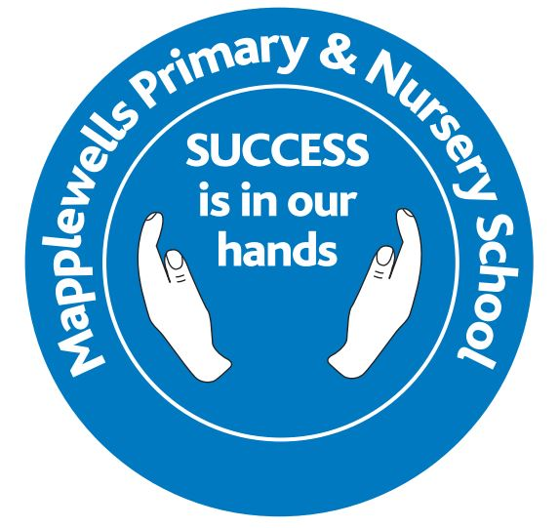
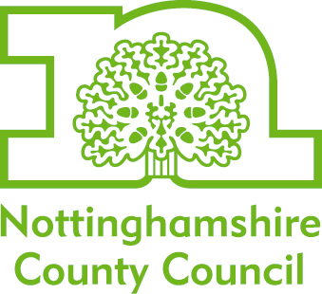

Web | www.nottinghamshire.gov.uk
Direct Line | 01623 434043
Fax Number | 01623 434046
E Mail | Schoolcatering.admin@nottscc.gov.uk

Welcome to our school dinners

Dear parent/guardian,

Your School Chef at Mapplewells Primary & Nursery School is Miss Rogers.

At Nottinghamshire County Council we recognise the importance a balanced, healthy meal plays in children’s lives. That’s why we aim to make our school dinners as enticing and enjoyable as possible.

Our Menus
Our menus run on a three week cycle and are amended twice a year (in summer and winter) to incorporate seasonal changes. This cycle length ensures adequate variety for pupils during the school term.

Before being placed in schools, our menus are subject to rigorous testing from the most discerning of critics, the pupils! We gather essential feedback on our meals to make sure we’re giving children what they want. So before placing new dishes on the menus, we run recipe testing events in schools to ensure they are a hit with the children.

In addition to this our menus are analysed through specialist software which measures the nutrient levels of each dish. This ensures that they comply with the Government’s 14 national nutritional standards for school meals.

These standards were put in place to ensure that children received minimum and maximum levels of nutrients in their school meals. So you can rest assured that your children are getting healthy and balanced meals to maintain energy and concentration levels throughout the day.

Our Ingredients
For our menus, we have sourced a range of local farmers and producers to supply some of the best ingredients from across the county. This includes:

- fresh meat that is bred and reared locally and supplied by a local butcher
- fresh, free range eggs
- locally produced milk
- fresh, seasonal fruit and vegetables - grown locally where possible.

We take these fresh ingredients and prepare meals on site, giving our cooks tighter control over meal content. This means we can ensure all our dishes use:

- whole cuts of meat – not minced or reformed
- MSC accredited fish – ensuring it is sourced from sustainable stocks
- sweeteners form natural sources such as locally produced honey
- no added salt or unnecessary preservatives.

Keeping you up to date
You can view all of our menus by visiting our website at www.nottinghamshire.gov.uk/schooldinners. Here you’ll be able to see what’s on offer, view pictures of the meals and find out more about Nottinghamshire school dinners.

Cost of school dinners
The current cost of a school meal is £3.20 per day. This covers the main meal and dessert of the day.

Universal free infant school dinners
Since September 2014 all children in reception, year 1 and year 2 at state-funded schools in England have been eligible for free school meals, as part of the national Universal Free Infant School Meals scheme.

Free school dinners
You may be entitled to claim free school dinners for your child/children if you are in receipt of certain benefits. To find out more about this and apply for free school meals, please visit our website at www.nottinghamshire.gov.uk or alternatively contact us on 0300 500 80 80.

Special diets
We are keen to ensure that pupils can enjoy school meals, regardless of their special requirements. We therefore work with pupils, parents and our school chefs where necessary to accommodate medical dietary requirements.

If your child has any medical dietary requirements but you would like them to stay for a school dinner, please contact us on 01623 434043 so we can discuss their needs.

If you have any further queries regarding school meals, please contact us using the details at the top of this letter.

Yours faithfully,

Area Catering Manager
Nottinghamshire County Council

