 |  | Autumn | Spring | Summer
F1 | Strand (s)  (taken from KKPDs) | Drawing  Study of great artists, architects and designers  Sculpture | Painting  Study of great artists, architects and designers  Analysing and evaluating  Sculpture | Drawing  Painting  Use colour, pattern, texture, line, form, space and shape
F1 | KKPDs  (and subject content choices) | Drawing  ADN.2 know how to effectively make marks on paper - Julia King – “fireworks on the 4th” Chalk art  ADN.5 know how to represent a person – family portraits  ADN.4 know and practice a range of gross motor movements that support the mechanics of drawing - outdoor play  Painting  ADN.9 know the names of all primary colours - Naidu Elangoven - mouth painting – Diwali lamp painting used as inspiration  ADN.11 know that different resources can be used for painting - sponge painting world peace day pictures  Sculpture  ADN.13 know how to make snips in paper using scissors - cutting activity in provision  ADN.16 know how to use a rolling pin to alter the appearance of malleable materials - play dough table  ADN.14 know how to select one-handed tools for different purposes  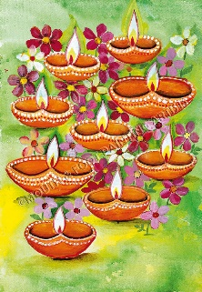  Naidu Elangoven  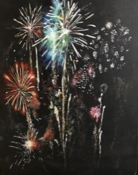  Julia King | Drawing  ADN.6 know how to use drawing to represent ideas  ADN.7 know that drawing communicate meaning  Painting  ADN.8 know paint can be used to capture known experiences  Study of great artists, architects and designers  ADN.17 know what an artist is  ADN.18 know artists who are in the local community - Paul Lillie Nottingham artist (cotgrave woods) go to forest school to look at trees and colours  ADN.19 know how to create a piece of artwork - Tyronne Hoerler aboriginal art  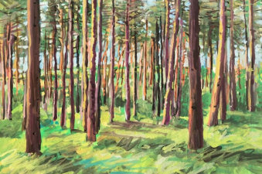  Paul Lillie  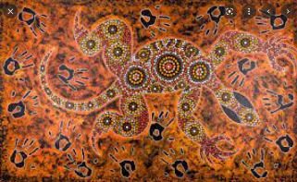  Tyronne Hoerler | Drawing  ADN.1 know how to hold a pencil demonstrating, using a developmentally appropriate grip - fine motor activities available in provision  ADN.12 know how to explore and select materials, expressing their own ideas - Nancy Azara – leaf rubbing, children to choose what media to use to rub the leaves.  Painting  ADN.10 know how to explore colour mixing to create different colours. Art from africa -mix colours for painting.  Use colour, pattern, texture, line, form, space and shape  ADN.3 know how to use closed shapes with continuous lines  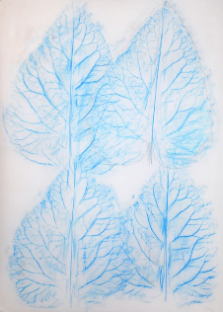  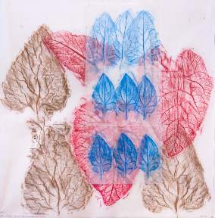  Nancy Azara  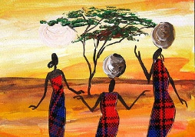  Sarah Shiundu
F1 | Rationale for content choices | Current Learning  Children will begin to explore how to make marks and how the way that they move can affect the marks that they make. They will learn about the primary colours and use this knowledge when painting with different resources when creating art for world Peace Day. The children will begin to explore sculpture in art through playdough activities and salt dough creations when making Diva lamps.  Future Learning  In the Autumn term the children will learn the basics needed to create artwork, what is artwork? What can it show? and the different ways that artwork can be created. This will support them when creating artwork and sculptures linked to artists around the world in KS1 and KS2 by giving the basic skills and understanding of how to create art through mark making and physical skills such as cutting and using tools.  Children will also look at some art from different cultures, this will link to art that is explored in KS1 and KS2 from around the world.  In the Autumn term children will learn about colour which will be developed further in year 3 and year 4/5 when colours are used to create different moods in art.  Curriculum Links  During this term children will be introduced to different religious celebrations, this links to the RE curriculum. | Current Learning  Children will learn what an artist is and then look in more detail about an artist that is local to them. During this term the children will have a go at creating a piece of artwork that is inspired by an artist from Australia and Nottingham. Children will deepen their understanding of drawing and how it can be used to communicate a meaning.  Previous Learning  Children will draw on knowledge from the autumn term about how to effectively make marks on paper and create artwork to learn about different artists.  Future Learning  The children will learn through their own artwork and the artwork of different local artists about how experiences can be portrayed in a piece of art, this knowledge will then be used again in year 1/2 where children will use their experience to create artwork and again in year 6 where children will interpret artwork to find the message that the artist is trying to convey.  The children will explore a local artist, which will link to the work of local artists in F2 and again in Yr3/4.  Curriculum Links  During this term, the children will explore aboriginal art from Australia. This links to the geography curriculum and work on Australia in KS1 when children learn about the 7 continents. | Current Learning  Children will learn more about colour and that they can be mixed to create new colours whilst creating a picture inspired by an African fairytale. They will also be given the opportunity to choose their own resources to express their thoughts and idea through art via a leaf rubbing activity.  Previous Learning  Work on plants and leaves will draw on previous work about how plants grow from the Spring term.  Future Learning  In F1 children will be taught how to correctly hold a pencil and other writing materials which is a skill that will be used continuously throughout the year groups in order to create art with different tools and equipment.  Curriculum Links  The children will explore art from Africa, this will link to the work completed in year 1/2 about the 7 continents.  The work on plants and leaves will link to the science curriculum in Year 1/2 and 3/4.
F1 | Enquiry Question | A: Are Celebrations always positive?  B: Who is significant? | A: Where would you like to explore?  B: What makes Britain great? | A: Is art all around us?  B: Can nature create art?
F1 | Subject Vehicle | Dr / En / Dis | Dr / En / Dis | Dr / En / Dis
End Points  F1 | Children should be able to:  Recall the knowledge specified within the KKPDs for Nursery.  Use mark-making or drawing to represent ideas.  Talk about colours and how they can be mixed to make different colours.  Use paint to capture known experiences.  Talk about the tools and materials they used for different purposes.  Talk about what an artist is and begin to name artists.  Share their creations with others.  Create simple representations of people and other things.
F2 | Strand (s)  (taken from KKPDs) | Use colour, pattern, texture, line, form, space and shape  Drawing  Sculpture | Use colour, pattern, texture, line, form, space and shape  Drawing  Painting  Study of great artists, architects and designers | Drawing  Analysing and evaluating  Study of great artists, architects and designers  Painting
F2 | KKPDs  (and subject content choices) | Drawing  ADR.1 know how to use anti-clockwise movements  ADR.2 know how to retrace lines on their own artwork  ADR.6 know how use the space available to make choices in their drawings  ADR.11 know how to use drawing to communicate and express ideas and feelings  Painting  ADR.14 know that paint can be used to capture imagination ow how  ADR.15 know how to select colour for purpose  ADR.19 know how to use a paintbrush to create a desired effect  ADR.20 know how to use a variety of tools when painting (e.g. brush, sponges, fingers, hands, sticks, sponge rollers) Pramod Sahu – Rangoli Pattern  Sculpture  ADR.21 know how to effectively and safely use simple tools to change materials  ADR.22 know how to use and experiment with a variety of materials and techniques Cai Gu-Qiang – Powderpaint fireworks  ADR.25 know how to select, cut, assemble, tear, stick and collage different materials – cutting activities available in provision  ADR.26 know how to manipulate malleable materials that are both soft or rigid (for example clay, plasticine and dough) – play dough available in  provision  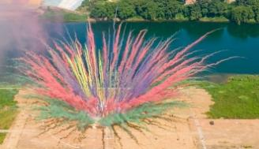  Cai Gu-Qiang – Powderpaint fireworks  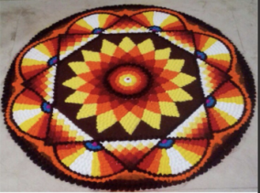  Pramod Sahu | Use colour, pattern, texture, line, form, space and shape  ADR.8 know how to create a simple pattern  Drawing  ADR.12 know and understand the term observational drawing Observational drawing session and in continuous provision creative area. Visit somewhere in Sutton- observational drawing.  ADR.13 know what is good about their drawing  Painting  ADR.16 know the names of all primary and a wider range of secondary colours  ADR.17 know how to mix paint to create secondary colours.  ADR.18 know how to use paint to lighten or darken a colour  ADR.23 know how to manipulate materials to create a desired outcome  ADR.4 know how to select and explain their choice of materials  Study of great artists, architects and designers  ADR.27 know how to explore and discuss artwork from the past and present  ADR.29 know who artists are within the local community and wider world and how they inspire others Rachel Thighe – local artist (birmingham) abstract picture of London/ Nottingham  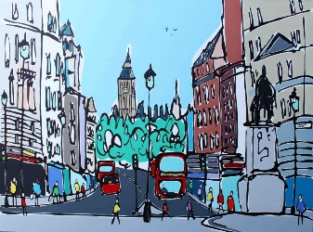  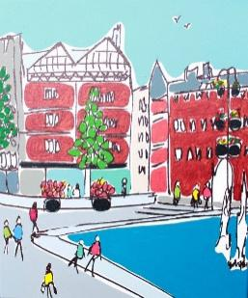  Rachel Thighe – local artist (birmingham) abstract picture of London/ Nottingham | Drawing  ADR.3 know how to hold a pencil using the tripod grip  ADR.4 know how to apply pressure to create different effects  ADR.5 know and securely demonstrate a range of gross motor movements, which underpin the mechanics of drawing Outdoor play  ADR.7 know different effects can be made from the way which you use the medium, (e.g. wax crayon for rubbing) Creative activities set up for children with different media to use  Study of great artists, architects and designers  ADR.27 know how to explore and discuss artwork from the past and present Van Gogh  ADR.28 know how to create a representation of famous artwork  ADR.30 know the similarities between artists and illustrator  Drawing  ADR.9 know how to draw a person including facial features Mirrors available in creative area  ADR.10 know how to draw a detailed figure taking shape, form and perspective into consideration
F2 | Rationale for content choices | Current Learning  Children will create chalk fireworks and rangoli patterns which will support the learning that different resources can be used in art. Children will have access to a playdough table which will develop their skills and knowledge surrounding sculpture.  Previous Learning  The children will draw on knowledge from F1 about capturing experience in art and have a go at creating their own art that communicates feeling and experience. Children will reactivate knowledge gained in F1 about what an artist is as they learn about local artists and artists from the wider world.  Future Learning  Portraying feeling and ideas in art will then be explored again in KS1 when children use experience in artwork and in year 4/5 when the children will use different colours in art to create a mood.  Curriculum Links  Children will draw on knowledge of bonfire night and Diwali from F1 and use this to inform their artwork. | Current Learning  Children will learn about observational drawing and use this experience to evaluate their work. The children will continue to explore colours through paint to mix and change colours. Children will learn about a local artist and use her work as inspiration to create their own art piece.  Previous Learning  Children will draw on knowledge from F1 about what an artist is and local artists to explore some more local artwork.  Future Learning  Children will begin to evaluate their artwork and what is good about it, this will link to comparing similarities and differences between their work and the work of an artist in year 1/2. This knowledge will then be used further in KS2 when the children evaluate their work and use this evaluation to refine their work.  Children will explore a local artist which links to local artists that are explored again in Year 3/4.  Curriculum Links  Children will learn about artists in their local area which links to the geography curriculum around where we live. | Current Learning  Children will consolidate learning of how to use different tools and techniques in their artwork. The children will explore art from past and present and complete evaluations. The children will look at the environment around them to discover if art is all around us and how the natural world impacts it.  Previous Learning  Children will draw on the knowledge gained in F1 about how to hold a pencil and represent a person and adding more detail.  Future Learning  The children will learn how to draw using more detail such as a person with facial features and begin to explore how this figure can incorporate shape form and perspective. This knowledge will be reactivated in year 1/2 when children learn about how lines can take different forms and how shapes can be used to create individual artwork.
F2 | Enquiry Question | A: Are Celebrations always positive?  B: Who is significant? | A: Where would you like to explore?  B: What makes Britain great? | A: Is art all around us?  B: Can nature create art?
F2 | Subject Vehicle | Dr / En / Dis | Dr / En / Dis | Dr / En / Dis
End Points  F2 | Children should be able to:  Recall the knowledge specified within the KKPDs for Reception.  Use mark-making or drawing to communicate ideas and feelings.  Talk about how different media can be used to create different effects.  Talk about how to draw a person using different features.  Talk about how to safely use and explore a variety of materials, tools and techniques, experimenting with colour, design, texture, form and function.  Share their creations, explaining the process they have used.  Discuss how artists inspire others.  Recognise and describe key features of their own and others’ work
Year 1/ 2  Cycle B | Strand (s)  (taken from KKPDs) |  | Use colour, pattern, texture, line, form, space and shape  Painting  Sketchbooks  Study of great artists, architects and designers | Use colour, pattern, texture, line, form, space and shape  Drawing  Study of great artists, architects and designers
Year 1/ 2  Cycle B | KKPDs  (and subject content choices) | No new Art KKPDs are taught during this term.  Instead, the art sticky knowledge from this year’s KKPDs, along with other sticky knowledge from previous year groups that has been identified as needing to be recapped, is re-covered through our flashcard assessment routine. | Use colour, pattern, texture, line, form, space and shape  AD1.2 know how lines can take different forms (e.g. curved, wavy, zigzag) (S)  AD2.1 know how to use lines and shapes to begin to show movement, contours, and feelings in individual artwork (D)  AD2.2 know how to use fine and broad media to develop control of line, shape and pattern (D)  Painting  AD1.7 know how to use painting to develop and share ideas, using a range of different materials  AD1.8 know the name of primary and secondary colours  AD1.9 know how to use a variety of tools when painting with increasing control (e.g. brush, sponges, fingers, hands, sticks, sponge rollers)  AD2.8 know how to produce paintings based on experiences or imagination, using a range of different materials John Dyer - Spiritual Butterflies, imagine what the rainforest is like, children create their own vision.  AD2.9 know how to mix paint to create all the secondary colours  AD2.10 know how to create brown with paint  AD2.11 know how to create tints with paint by adding white  AD2.12 know how to create tones with paint by adding black  AD2.13 know how to begin to use a range of painting techniques such as dotting, scratching and splashing - Painting of Uluru by Danny Eastwood  Sketchbooks  AD 1.15 Know that sketchbooks are places to explore and experiment, express likes and dislikes, research and collect  AD2.17 Begin to develop sketchbook habits e.g. making mistakes and learning from them  Study of great artists, architects and designers  AD1.16 know how to describe what can be seen and give an opinion about the work of an artist, craft maker and / or designer  AD1.17 know how to describe similarities and differences between their own work and that of an artist, craft maker and / or designer  AD2.18 know how artists, craft makers and/or designers have used colour, pattern and shape  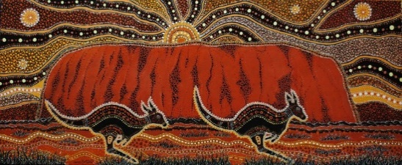  Painting of Uluru by Danny Eastwood  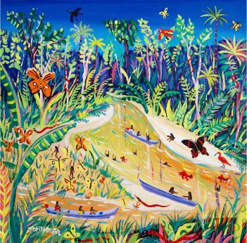  John Dyer Painting. Spiritual Butterflies, Rio Gregório, Amazon Rainforest, Brazil (choose different area to use different techniques) | Use colour, pattern, texture, line, form, space and shape  AD1.1 know and use lines and geometric shapes to create individual artwork (D)  AD1.2 know how lines can take different forms (e.g. curved, wavy, zigzag) (S)  AD1.3 know how to create rubbings (e.g. from a textured surface) (P)  AD1.4 know how to create a repeating pattern (for example in print) (D)  AD2.1 know how to use lines and shapes to begin to show movement, contours, and feelings in individual artwork (D)  AD2.2 know how to use fine and broad media to develop control of line, shape and pattern (D)  AD2.4 know how to create a printed piece of art by pressing, rolling, rubbing and stamping (P)  Drawing  AD1.5 know how to use drawing to develop and share ideas using a range of different materials (D)  AD1.6 know how to experiment with pencils to create lines of different thickness in drawings (D)  AD2.5 know how to produce drawings based on experiences or imagination using a range of different materials (for example pencil, charcoal, ink) (D)  AD2.6 know how to use pencil to create different tones (D)  AD2.7 know and practice basic drawing techniques (for example stippling and blending) (P)  Study of great artists, architects and designers  AD1.16 know how to describe what can be seen and give an opinion about the work of an artist, craft maker and / or designer (S)  AD1.17 know how to describe similarities and differences between their own work and that of an artist, craft maker and / or designer (S)  AD2.18 know how artists, craft makers and/or designers have used colour, pattern and shape (S)  AD2.19 know how to create a piece of art in response to the work of another artist, craft maker and / or designer (P)  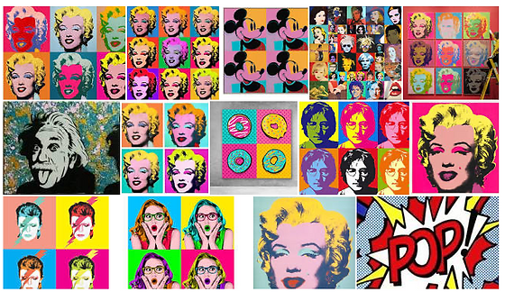  Andy Warhol- Pop art
Year 1/ 2  Cycle B | Rationale for content choices |  | Current Learning  Children will use paintings from different countries as inspiration to explore colour mixing, creating different tones. They will use this paint to explore different techniques such as splashing and dotting.  Previous Learning Y1  The children will build on knowledge of using tools such as rolling pins to manipulate materials in F1 on the playdough table to create particular effects on materials.  Children will build on knowledge of primary and secondary colours in F1 and F2  The children will explore artists that build upon the knowledge of British artists in F1 and also artists in the wider world in F2.  Children will be deepening their learning about Australia from F1.  Previous Learning Y2  Children in year 2 will draw on knowledge from year 1 of the secondary colours when they begin to mix colours.  Future Learning Y1  Children in year 1 will move on to add black and white to paint to change the tone and will use knowledge of painting skills to experiment with a range of new painting skills such as scratching and splashing.  Future Learning Y2  The children will learn about using different media to create pattern which will prepare them for year 6 when the children will use print to create patterns.  Knowledge of how to use tools will be reactivating in KS2 when the children will use different tools and techniques to create sculpture.  This knowledge will then develop when looking at more artists from different countries, cultures and time periods in KS2.  Curriculum Links  Art from the wider world links to the geography curriculum about geographical knowledge of places. | Current learning:  Children will learn about the artist Andy Warhole and how he make his mark with the pop art movement and transformed the idea of art in the 1960’s.  Previous learning Y1  The children will build on knowledge of previously learnt artist and how Warhol’s paintings are different to these. Children will build on their use of primary and secondary colour that was gained in F2.  Previous knowledge Y2  Children will build on their knowledge of creating lines from year 1.  Future Learning Y1  Children will develop their drawing skills by using tones and how to use stippling and blending.  Future Learning Y2  Children will continue to use a range of tools and techniques in KS2 and they will be looking at more artists from around the world so they will be able to compare and draw on similarities and differences  Curriculum Links  The art we will be learning about is from the 1960’s in history and we will be learning about a range of historical events that happened during this period.
Year 1/ 2  Cycle B | Enquiry Question | How does the past affect the future? | Would I enjoy living anywhere in the world? | How do we make our mark?
Year 1/ 2  Cycle B | Subject Vehicle | Dr / En / Dis | Dr / En / Dis | Dr / En / Dis
End Point  Year 1 | Children should be able to:  Recall the knowledge specified within the KKPDs for Year 1.  Talk about the use of shape, line and pattern in art.  Experiment with different media.  Use different tools to paint with.  Talk about how to manipulate malleable materials.  Begin to use sketchbooks to record ideas.  Give opinions about the work of others and talk about similarities and differences to their artwork.  Can show interest in and describe what they think about the work of others.
End Point  Year 2 | Children should be able to:  Recall the knowledge specified within the KKPDs for Year 2.  Make choices about the art elements to show movement, contours and feelings.  Use different sketching techniques based on experiences or imagination.  Talk about how tints and shades can be created using paint.  Create sculptures for a purpose (i.e. use of clay).  Use sketchbooks as a space to make mistakes and learn from them.  Talk about how artists, craft makers and designers have used colour, pattern and shape for effect.  When looking at creative work, can express clear preferences and give some reasons for these.  Deliberately choose to use particular techniques for a given purpose.
Year 3/4 | Strand (s)  (taken from KKPDs) | Use colour, pattern, texture, line, form, space and shape  Drawing  Sculpture  Study of great artists, architects and designers  Using Sketchbooks |  | Sculpture  Use colour, pattern, texture, line, form, space and shape  Study of great artists, architects and designers
Year 3/4 | KKPDs  (and subject content choices) | Study of great artists, architects and designers  AD4.12 know and experiment with the styles used by other artists, architects and / or designers - Roman Bath – Simon Harmer  Drawing  AD3.4 know how to produce drawings with increasing accuracy and control, experimenting with different materials  AD4.4 know how to use shading to convey shape depth (for example in a landscape)  Use colour, pattern, texture, line, form, space and shape  AD3.2 know how to create a sense of proportion in their own artwork (P)  AD4.1 know how to use line, tint, tone, shape, form and colour to create a sense of movement in artwork.  Using Sketchbooks  AD4.11 know how to use sketchbooks to collate ideas from a range of sources to inform a final piece of art using different tools and techniques (e.g. including materials, photographs, sketches etc)  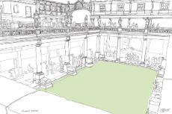o  Roman Bath – Simon Harmer | No new Art KKPDs are taught during this term.  Instead, the art sticky knowledge from this year’s KKPDs, along with other sticky knowledge from previous year groups that has been identified as needing to be recapped, is re-covered through our flashcard assessment routine. | Use colour, pattern, texture, line, form, space and shape  AD3.1 know how to use line, tint, tone, shape, form and colour to create a sense of dimension (P)  AD4.2 know how to produce artwork using increasingly accurate proportion and scale (P)  Painting  AD4.7 know how to use watercolour to use different types of paints to produce washes for backgrounds and add detail (for example water colours, inks)  AD3.9 know how to experiment with different types of brush for a purpose (P)  AD3.10 know how to use and develop a greater range of painting techniques  Study of great artists, architects and designers  AD3.17 know when art is from different cultures (S)  AD3.16 know when art is from different historical periods – Egyptian Jewellery  AD3.14 know and identify the techniques used by different artists, architects and / or designers (S)  AD4.14 know how art provides a viewpoint about the past (S)  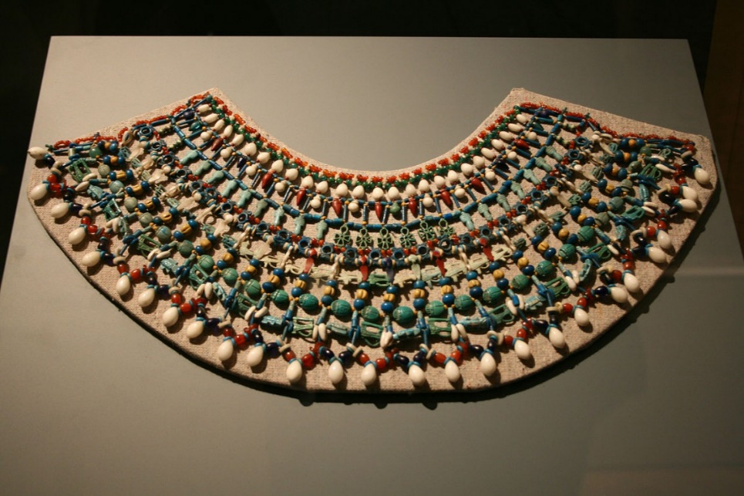  Ancient Egyptian jewellery – patterns, jewels, clay.  Sculpture  AD3.12 know how to use techniques to create a sculpture (for example, coiling, pinching, slab construction etc). (D)  AD3.11 know how to produce sculpture with increasing accuracy, control and purpose, experimenting with different materials. (P)  AD4.8 know how to produce sculpture (P) with increased control and accuracy, experimenting with different materials (D)  AD4.9 know further joining techniques (for example fold, insert, slot, tie, wrap, tabs) (S)  AD4.10 know how to add finer detail to enhance the purpose and aesthetics of the sculpture using appropriate tools – knives, chisel, hammer. (D)
Year 3/4 | Rationale for content choices | Current Learning  The children will explore artwork of roman baths to explore different art styles and to create artwork with a viewpoint, they will use this inspiration to learn more about using line, tone and tint.  Previous Learning Y3  Children will draw on knowledge of art form different historical periods from year 1/2 to understand more about how art can provide a viewpoint about the past.  Previous Learning Y4  Children will draw on knowledge gained in year 3 about using different materials when drawing to increase accuracy when using line, tone and shape to convey movement in their art.  Future Learning Y3  Knowledge about using materials when drawing will be built upon again in year 4 when the children experiment with new drawing techniques such as cross hatching and smudging.  Future Learning Y4  Knowledge about tone and perspective will be built upon again in year 5/6 when the children will learn more about perspective art.  Curriculum Links  The children will learn about artwork form different historical periods; this will link to the history curriculum. | No new Art KKPDs are taught during this term.  Instead, the art sticky knowledge from this year’s KKPDs, along with other sticky knowledge from previous year groups that has been identified as needing to be recapped, is re-covered through our flashcard assessment routine. | Current Learning  Children will be exploring art from different time periods, they will look at an ancient sculpture to inspire their own sculptures. They children will explore how to use different tools to create sculpture.  Previous Learning Y3  The children will use knowledge and skills gained in early years from molding playdough to create a sculpture.  The children will be drawing on knowledge about manipulating materials like clay from year 1/2 to create a sculpture.  Previous Learning Y4  The children will draw on knowledge gained in year 3 about using a range of tools in art when creating a sculpture using tools in year 4.  Future Learning Y3  Children will use knowledge of artists such as art from different cultures and time periods to be able to explain some of the features of the sculptures in year 4.  Future Learning Y4  Sculpting techniques will then be used and built upon in year 6 when children will combine techniques and different materials to create a sculpture.  Curriculum Links  The children will learn about artwork form different historical periods; this will link to the history curriculum.  This will link to history and Geography as the sculptures will be an Egyptian Scarab beetle.  Links to DT knowledge when making a sculpture.
Year 3/4 | Enquiry Question | How do we benefit from change? | Why is life drawn to rivers? | Should a secret ever be shared?
Year 3/4 | Subject Vehicle | Dr / En / Dis | Dr / En / Dis | Dr / En / Dis
End Point  Year 3 | Children should be able to:  Recall the knowledge specified within the KKPDs for Year 3.  Talk about how the art elements can be used to create a sense of dimension (i.e. use of proportion).  Use different grades of pencil for effect (i.e. tone, texture, atmosphere and shadow).  Talk about a range of painting tools and techniques.  Use different techniques to create sculptures.  Use a sketchbook as a learning journey.  Talk about art from different cultures and historical periods.  Compare and contrast different pieces of art.  Reflect upon what they like and dislike about their work in order to improve it.
End Point  Year 4 | Children should be able to:  Recall the knowledge specified within the KKPDs for Year 4.  Talk about how the art elements can be used to create a sense of movement, proportion and scale.  Develop a range of further sketching techniques.  Talk about the use of watercolour and washes in painting.  Talk about a range of joining techniques and how they can enhance a sculpture.  Document the use of different tools and techniques in sketchbooks.  Talk about how artists, designers and architects have developed their style.  Talk about the links between art and history.  Reflect upon their own work and use comparisons with the work of others (pupils and artists) to identify how to improve.  Apply the technical skills they are learning to improve the quality of their work
Year 5/6 | Strand (s)  (taken from KKPDs) | Use colour, pattern, texture, line, form, space and shape  Drawing  Study of great artists, architects and designers  Using Sketchbooks | Previous Strands Recapped | Sketchbooks  Painting  Sculpture
Year 5/6 | KKPDs  (and subject content choices) | Study of great artists, architects and designers  AD5.16 know how to research the work of an artist, architect and / or designer and use their work to replicate a style (D)  AD5.19 know reasons why artists, architects and designers make decisions based on cultural influences (S)  AD6.11 know and explain how their own artwork has been influenced by a famous artist, architect and or designer Henry Moore - underground WW2 sketches.(D)  AD6.12 know why art can be very abstract and interpret what message the artist, architect and or designer is trying to convey (D)  Drawing  AD5.6 know how to produce drawings with increasing accuracy, control and close observation, experimenting with different materials (for example pencil, charcoal, ink)  AD5.7 know how to use previously taught drawing techniques to create mood (D)  AD6.4 know how to draw with precision using previous taught techniques, using different gradient pencils or other materials for effect sketching pencils  Use colour, pattern, texture, line, form, space and shape  AD5.2 know how to create perspective in art using one point of perspective (P)  AD6.1 know how to apply knowledge of proportion, depth, perspective, form and space to create effective pieces of art  Using Sketchbooks  AD5.15 know how to use sketchbooks to capture and develop ideas using different tools and techniques to refine their own artwork  AD6.8 know how to use sketchbooks to record observations and develop own techniques, commenting on the effectiveness of these  AD6.9 know how to think critically about ideas, captured from a range of sources, in sketchbooks to justify decisions in their own artwork  AD6.10 know and explain why different tools and techniques have been used to create art when capturing ideas in the sketchbooks  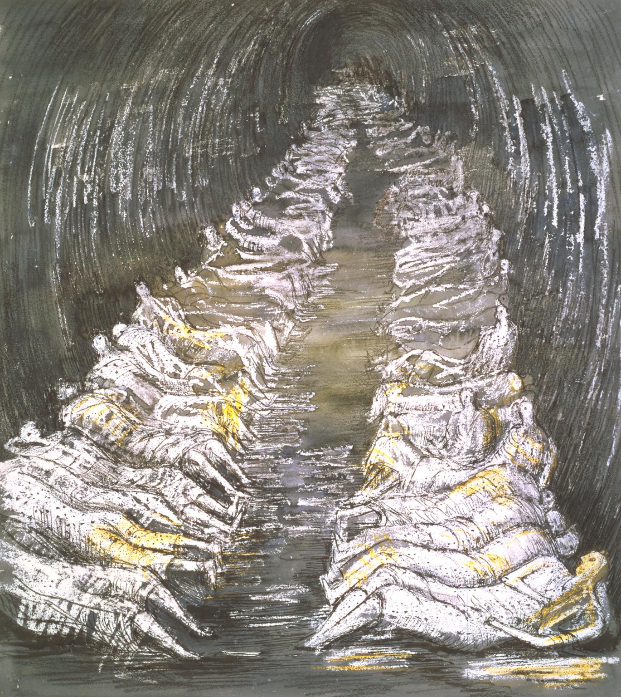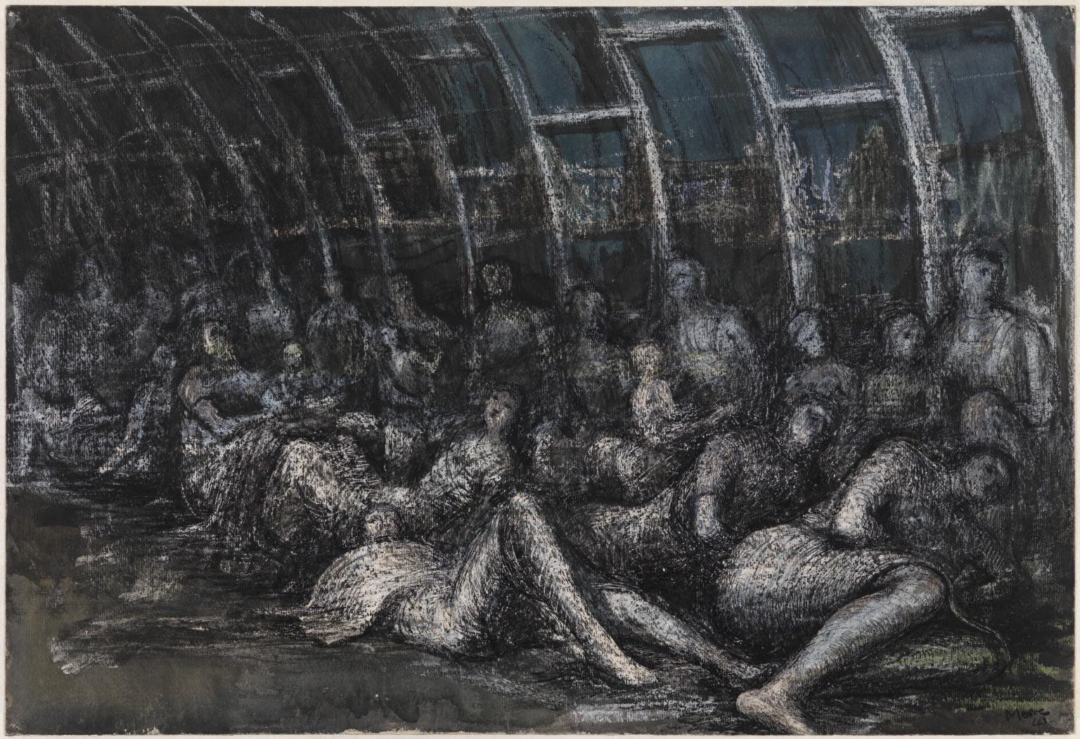  Henry Moore - underground WW2 sketches. | No new Art KKPDs are taught during this term.  Instead, the art sticky knowledge from this year’s KKPDs, along with other sticky knowledge from previous year groups that has been identified as needing to be recapped, is re-covered through our flashcard assessment routine. | Sculpture  AD5.13 know how to produce sculptures with increasing accuracy, control, purpose and close observation, experimenting with different materials (including natural versus manmade) (D) Viking brooch  AD5.14 know how to develop further techniques to create a sculpture (for example, carving, modelling, casting, constructing etc) (D)  AD6.6 know how to combine techniques and different materials, according to purpose and aesthetics, to create a sculpture (for example combining wire work with papier mache , salt dough etc) (D)  AD6.7 know how to join different materials both for strength and aesthetics (D)  Painting  AD5.6 know how to produce drawings with control, accuracy and close observation (P), experimenting with different materials (for example pencil, charcoal, ink) (D)  AD6.5 know how to make inventive choices as to paint type and technique to create a desired outcome (S) colour wheels, primary colour, colour schemes, tools, paintbrushes, stippling.  Sketchbook  AD5.15 know how to use sketchbooks to capture and develop ideas using different tools and techniques to refine their own artwork (S)  AD6.8 know how to use sketchbooks to record observations and develop own techniques, commenting on the effectiveness of these (S)  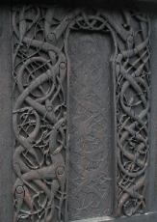 Celtic knot and weave pattern  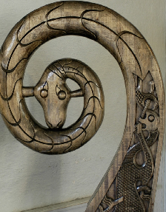Sculpture animal designs  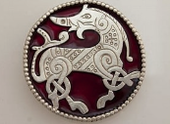  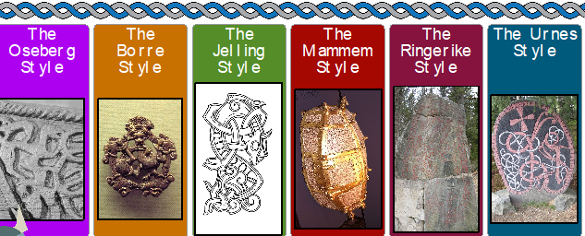  The 6 styles of Viking art used in jewellery and sculpture  Alexander Calder  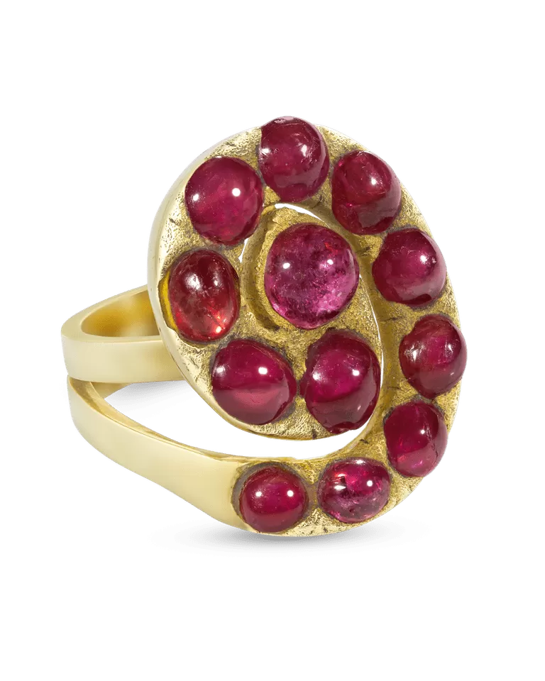
Year 5/6 | Rationale for content choices | Current Learning  The children will look at Henry Moore’s sketches to learn about line, sketching, tone and shading using different materials such as pencils and charcoal. They will be researching and evaluating a famous artist and using their research and own opinions to justify decisions in their own artwork.  Previous Learning Y5  Children will draw on knowledge of proportions taught in F2,  Children will use drawing techniques that have built from holding a pencil correctly in F1 to shading in year 4. This will allow them to create effect with pencils.  Children draw on knowledge of sketching in year 3  Children will draw on knowledge of London from F2 when exploring Henry Moore’s WW2 London underground sketches.  The children will be able to use their knowledge of evaluation in F2 and comparing their artwork to artists in year 1/2 in order to explain how their art has been influenced by the artists that they have studies over the key stages.  Children will draw on knowledge from Y4 around showing body language in art when creating sketches based on Henry Moore’s artwork.  Previous Learning Y6  Children in Y6 will draw on knowledge from Y5 about cultural influences on artwork when exploring Henry Moore’s work and the reasons behind it.  Children will use skills how to use their sketchbook to capture ideas when learning more about commenting on effectiveness on the techniques explored.  Future Learning Y5  Children will use knowledge of how to produce drawing with accuracy again in Y6 when drawing with precision using drawing techniques chosen for a reason.  Children will use their knowledge of artists and how to research the work of an artist to explain in more detail how their art has been influenced by others.  Future Learning in Year 6 (learning in year 7)  The children will use the knowledge gained in year 3 / 4 around landscape artists and techniques to draw a landscape using pencil in year 7.  The children will use their knowledge of how to evaluate and explore artists gained in KS2 when looking at artists in year 7.  - Working effectively in the style of the artists Van Gogh and Hundertwasser to create their own personalized outcomes.  - Draw an accurate landscape using pencil.  - Explore was resist technique, oil pastels and collage.  - Design a landscape from own photograph.  - Developing their art skills across a range of material areas to construct personalized landscape outcomes  Curriculum Links  WW2 sketches explored link to the History curriculum. | See previous content choices. | Current Learning  Children will be learning about the 6 art styles used by the Vikings and how the Vikings used these within their decoration and style of jewellery, in particular brooches. They will explore the different styles and then decide what style will be incorporated into their final brooch design. They will practice sketching Celtic knot and weave patterns to use within their final brooch designs. The children will explore sculpture techniques and will plan and design their final brooch design. They will produce this design using sculpture skills and salt dough. Painting their final design.  Previous Learning Y5  Children will use knowledge of patterns gained in F2 to create patterns through print.  Children will use knowledge gained in y4 around how to use line, tone and shape to represent figures and forms in movement to create a perspective art piece of Viking ships in motion.  Children will use knowledge from KS1 about art from different cultures and time periods when looking at a Viking brooch.  Previous Learning Y6  Children in Y6 will use knowledge gained in Y5 surrounding tools and techniques used to create sculpture when join materials for aesthetics and strength in Y6.  Future Learning Yr 5  Children will build on knowledge of sculpture again in Y6 when they use different materials such as clay and wire to create a sculpture of a Viking brooch. They will have the opportunity to combine techniques in their artwork.  Future Learning Y6 ( learning in Year 7)  Children will use the knowledge that they gained in foundation and year 1 /2 around aboriginal and Australian when creating Tinga Tinga style art in year 7.  Children will use the techniques gained when using watercolor in Y3 / 4 when exploring watercolor again to create effects in year 7.  Tinga Tinga Art  - Understand how to analyse an artist and construct an artist page.  - To be able to use a range of pencil skills to create an observational pencil drawing.  - To be confidently use the technique of watercolour blending to create a Tinga Tinga inspired outcome.  - Design own work in the style of the artist.  Curriculum Links  Viking ships will link to the History and Geography curriculum.
Year 5/6 | Enquiry Question | How can we learn from our mistakes? | What is our planet trying to tell us? | Is it better to create or destroy?
Year 5/6 | Subject Vehicle | Dr / En / Dis | Dr / En / Dis | Dr / En / Dis
End Point  Year 5 | Children should be able to:  Recall the knowledge specified within the KKPDs for Year 5.  Talk about how the art elements can be used to create the illusion of 3D art.  Talk about how to create mood in artwork.  Talk about transparency and layers in painting and how different brushes create different effects (i.e. texture).  Talk about the difference between natural and manmade materials.  Use a range of sculpting techniques.  Use sketchbooks to capture the development of ideas and processes.
End Point  Year 6 | Children should be able to:  Recall the knowledge specified within the KKPDs for Year 6.  Apply knowledge of the art elements.  Independently develop a range of ideas which show curiosity, imagination and originality.  Explain how to make inventive choices when painting to create a desired outcome.  Combine techniques and materials when producing sculptures, considering aesthetics and strength.  Use sketchbooks to capture and justify ideas and decisions, demonstrating critique.  Explain how their artwork has been influenced by artists, designers, architects, cultures or periods in history.  Independently take action to refine their technical and craft skills in order to improve their mastery of materials and techniques.  Provide a reasoned evaluation of both their own and professionals’ work which takes account of the starting points, intentions and context behind the work.  Produce artwork that explores political, social or environmental context.

