
Subject Specific Vocabulary
Family | A group of people who live together, usually related, who take care of each other.
Celebration | An event or social gathering to celebrate something special happening.
Festival | An event that celebrates a cultural, artistic or religious activity.
Religion | A faith where people worship a God or certain beliefs.
History | Events that have happened in the past.
Birthday | A celebration of how long a person has lived for in years.
Soldier | A person who fights for their country in a war or conflict.
Key Knowledge – Understanding the world - History
Age is the length of time that a person has lived or a thing has existed. E.g. ‘My age is…’
My family is made up of people I am related to or who takes care of me.
History is the past-things that have already happened.
Fireworks are used to celebrate on Bonfire Night in the UK. We learn about Guy Fawkes.
Poppies are worn on Remembrance day in the UK.
Key Knowledge – Understanding the world - RE
There are lots of reasons to celebrate.
Peace means showing love and care for each other.
Diwali is the festival of lights for Hindus.
Hanukkah is the festival of lights for Jews.
Christmas celebrates Jesus’ birth.
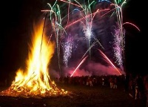 |  | 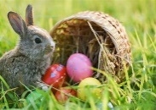
Bonfire Night | Christmas | Easter
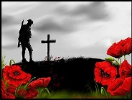 | 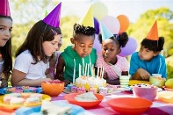 | 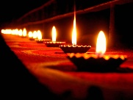
Remembrance Day | Birthday | Diwali
Significant Events
Texts we will explore
Foundation 1 – Spring Term
Geography: Where would you like to explore?
Foundation One – Spring Term
Geography - Where would I like to explore?
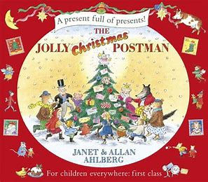 | Jolly Christmas Postman – Allan Ahlberg
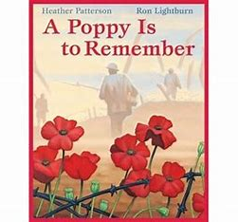 | A Poppy is to remember - Heather Patterson
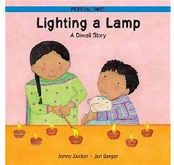 | Lighting a lamp: a Diwali story - Jonny Zucker
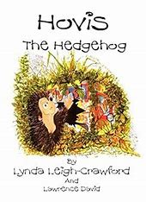 | Hovis the hedgehog - Lynda Leigh-Crawford
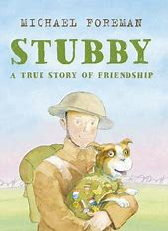 | Stubby - Michael Foreman

Timeline

