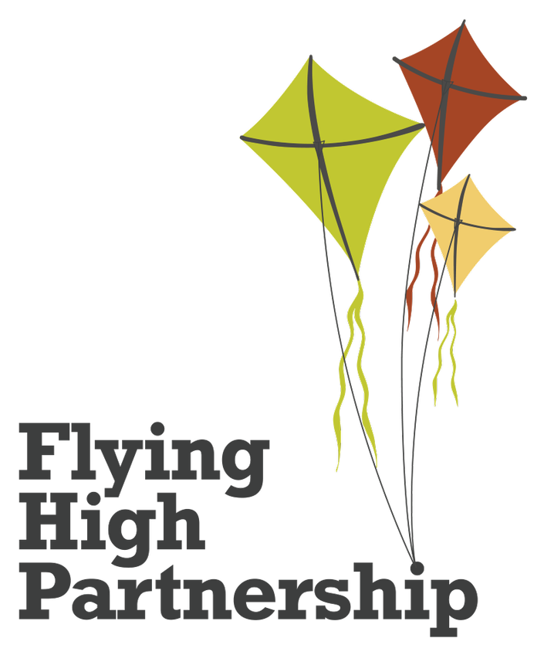

Science policy
Understanding the world and how to investigate it
Last reviewed on: | September 2026
Next review due by: | September 2027

Vision
Our FHP curriculum model, underpinned by current research and statutory documentation (such as the National Curriculum and EYFS framework), ensures our children will be well-rounded individuals who are prepared for the next stage of their journey. It will promote compassion, mutual understanding, integrity and a pursuit of excellence in order for our children to reach their potential and make a positive contribution to the wider world. Our enquiry-based approach takes children on a journey of memorable learning through rich and purposeful experiences, culminating in authentic outcomes which leave a social legacy. We communicate our vision through the acronym, ‘CHROME’.

Character and Heart to develop individuals who are resilient and show compassion and integrity.
Relevance to ensure our children’s backgrounds and needs, along with our current culture, climate and events, determine the content of our curriculum.
Opportunities to enable children to move beyond their lived experiences, further developing their cultural capital
Memorable learning to secure children with transferable knowledge they need for subsequent learning
Empowerment to enable children to be aspirational, reflect on their learning, take risks, be brave, ask questions, solve problems, evaluate, develop peer critique methods and take ownership of their learning to increase their cultural capital

Science Vision
At FHP, our science curriculum, underpinned by current research and the National Curriculum, contributes to ensuring our pupils are well-rounded individuals. Through science, we encourage pupils to explore the world around them and develop their natural curiosity to become knowledgeable, reasoned thinkers. By applying their learning through a working scientifically approach, children will utilise creativity, reasoning and problem-solving skills to answer questions they are posed and those they ask of themselves. We aim to help children understand that they have an important, everyday impact on the world around them – articulating this in ways that develop their oral and written skills and showcased through authentic outcomes. As a result, we intend to inspire children through an engaging science curriculum that hones in on the needs of the school and the individual pupils, helping them prepare for future learning and provide aspirations for future careers.

Aims
Our science curriculum aims for pupils to:
- develop scientific knowledge and conceptual understanding through the specific disciplines of biology, chemistry and physics
- develop understanding of the nature, processes and methods of science through different types of science enquiries that help them to answer scientific questions about the world around them
- gain the scientific knowledge required to understand the uses and implications of science, today and for the future.

We are aspirant for all children to leave Mapplewells Primary School as scientists and have clearly defined end points for each year group and the whole primary phase to ensure we meet this aim. Please see appendix A: ‘As Scientists’ for our end of primary phase poster.

Intent
At Mapplewells Primary School, our curriculum is based on the National Curriculum for Key Stages 1 & 2 and the Early Years Foundation Stage Framework. These documents stipulate the expectations which inform the intent of our curriculum, ensuring a high ambition for all. Further ambition is gleaned through the use of expert resources from the Science Association.
Statements from the National Curriculum for science and from the ‘understanding the world’ educational programme of the EYFS have been broken down and sequenced into strands and year groups. We call this a key knowledge progression document (KKPD). It contains key substantive, procedural and disciplinary knowledge that children need to know and remember.

Composite knowledge from the KKPD is mapped on to a whole school long-term plan and sequenced onto a science subject map. Links are made across year groups and subjects through deliberate and diverse content choices.
For example:
- Plants is taught in EYFS, Year 1, Year 2 and Year 3.
- Living things and their habitats is taught in EYFS, Year 2, Year 4, Year 5 and Year 6.
- Animals including humans is taught in all year groups.
- Materials is taught in EYFS, Year 1, Year 2, Year 3, Year 4 and Year 5
- Electricity is taught in EYFS, Year 4 and Year 6
- Forces and Magnets is taught in EYFS, Year 3 and Year 5.
- Light is taught in EYFS, Year 3 and Year 6.

Each science KKPD statement is broken down into component (granular) knowledge and key vocabulary and can be found in our component knowledge progression document (CKPD) These are used to support the creation of learning sequences and to identify ‘sticky knowledge’ – the most important knowledge children need to remember for the next stage.
Within the KKPD are clearly defined curriculum end points which capture the knowledge, skills and understanding that children should have at the end of each year. They build progressively over time so that children leave Year 6 well-prepared for the next stage of education as competent and capable scientists.
For subject leaders, they provide a clear overview of the end of year expectations for each year group, which will support the planning and assessment of the curriculum.
For teachers, they provide further clarity around what children should be able to do at the end of each year, using the knowledge they have gained from being taught the KKPDs. They support teachers to plan activities that help to develop children as effective scientists. They should be used to check what children know and how well they can apply this knowledge across the curriculum.
For children, they ensure that they receive an equitable curriculum which gives them the substantive, procedural and disciplinary knowledge needed to be successful in their future studies.
The science KKPD and CKPD are used by teachers to create learning sequences and objectives with the end points in mind. These are plotted on an enquiry or a discrete medium-term plan.
Please see Appendix B: ‘Curriculum Structure Flowchart’ for further information.

Implementation
The Mapplewells Primary School science curriculum is generally delivered through a discrete approach. Science can be delivered as an enhancer to an enquiry (when this enables children to answer the enquiry question to its fullest).
Individual lessons are planned in detail using our lesson design model. This has been informed by leading research such as Rosenshine’s principles of instruction. The model includes five, flexible elements:
- Reactivate
- Teach, facilitate, model
- Learning together
- Independent practice
- Reflection
We use a range of varied teaching strategies to deliver science lessons. We believe in whole-class teaching methods and we combine these with enquiry-based research activities. We encourage children to ask, as well as answer, scientific enquiry questions. We offer them the opportunity to use a range of informative sources to build up key foundational knowledge and concepts as well the application of a variety of working scientifically skills to encourage children to recognise the power of rational explanation and develop a sense of excitement and curiosity about natural phenomena. Scientific enquiries are crucial to our science learning and are used to immerse children within the different disciplines of science.
Our learning environments are used as immersive and instructional teaching tools. Learning journeys are organised with key knowledge and vocabulary accessible so that children can locate and use this key information easily and efficiently.

Impact
Our carefully planned curriculum is the model of progression in science. We strive for our children to know, remember and understand more of what they have been taught. Our carefully planned curriculum is the model of progression in science. We strive for our children to know, remember and understand more of what they have been taught.
Children in year 1-6 complete a post assessment to assess the knowledge they have retained during the topic.
Knowledge organisers are used as a point of reference to support the acquisition of key vocabulary and key knowledge and can be used for both retrieval and self-quizzing practices.
Interleaving assessment of our ‘sticky knowledge’ is carefully planned on medium term plans and displayed in our classrooms.
All assessment practices allow teachers to garner evidence towards the science curriculum end points and informs where subsequent teaching needs to focus to close any gaps. This evidence forms a capture of how well our children are performing across the school within science.
Our Partnership has developed a comprehensive subject leadership toolkit. We have ensured that all subject leaders have received training on this. The document provides a range of monitoring tools including a methodology for checking the quality of education that pupils receive in science. We call this methodology a ‘focused review’. This tool allows us to monitor, check and connect evidence together to form robust judgements about the quality of education that pupils receive in science. We use work scrutiny, pupil discussions and lesson visits effectively to achieve this.

Children with special educational needs and/or disabilities (SEND)
At our school we teach science to all children. Science forms part of the school curriculum to provide a broad and balanced education to all children. We want all our children to access an ambitious science curriculum. We believe in scaffolding up, and not dumbing down, the science curriculum. A number of adaptations are available for children who have additional barriers to their learning. These can be seen in our science adaptation document (appendix C). These have been shared with teachers to give them ideas on how to adapt lessons.
Where accessing reading materials could be a barrier (e.g., lowest 20% of readers), we include visual and audible scaffolds.

Staff professional learning
As part of the Flying High Partnership, our staff have access to a professional learning community, where science leads from all Partnership schools work together to share best practice, discuss scholarly developments and strategically develop and plan our vision for the next steps in our science curriculum. This expertise is then shared across the staff team through staff meetings and INSET training sessions.

Equal opportunities
It is important that teachers plan work that offers equal opportunity in respect of protected characteristics. For example:
- by ensuring that activities are carefully planned to meet the needs of all children and ensure scaffolds are available to the children who need more support
- by ensuring that science is taught to all and that the materials used provide a ‘mirror’ and ‘window’ to the wider world
- by ensuring that multi-cultural themes are explored so that children are encouraged to develop awareness, interest and tolerance towards people and places beyond their immediate experience

