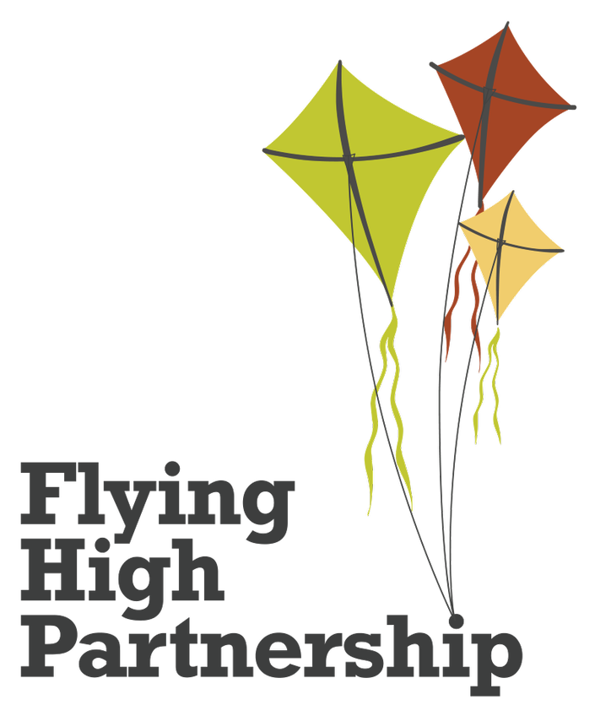

Geography policy
Exploring our world, how it works and our impact on it.
Last reviewed on: | September 2026
Next review due by: | September 2027

Vision
Our FHP curriculum model, underpinned by current research and statutory documentation (such as the National Curriculum and EYFS framework), ensures our children will be well-rounded individuals who are prepared for the next stage of their journey. It will promote compassion, mutual understanding, integrity and a pursuit of excellence in order for our children to reach their potential and make a positive contribution to the wider world. Our enquiry-based approach takes children on a journey of memorable learning through rich and purposeful experiences, culminating in authentic outcomes which leave a social legacy. We communicate our vision through the acronym, ‘CHROME’.

Character and Heart to develop individuals who are resilient and show compassion and integrity.
Relevance to ensure our children’s backgrounds and needs, along with our current culture, climate and events, determine the content of our curriculum.
Opportunities to enable children to move beyond their lived experiences, further developing their cultural capital.
Memorable learning to secure children with transferable knowledge they need for subsequent learning.
Empowerment to enable children to be aspirational, reflect on their learning, take risks, be brave, ask questions, solve problems, evaluate, develop peer critique methods and take ownership of their learning to increase their cultural capital.

Geography Vision

Geography enables children to develop their understanding of the impact and legacy they leave on the wider world. Through quality teaching, children will have the opportunity to build upon the cultural capital they need to be well-rounded individuals with the knowledge and skills to flourish in society. Through an enquiry-based approach, Geography encourages curiosity of how the world has formed to what it is today, as well as the sustainability challenges that now face the world. Children will harness an enthusiasm for Geography while continuously making relevant connections.

Aims
Our Geography curriculum aims for pupils to:
- develop contextual knowledge of the location of globally significant places – both terrestrial and marine – including their defining physical and human characteristics and how these provide a geographical context for understanding the actions of processes
- understand the processes that give rise to key physical and human geographical features of the world, how these are interdependent and how they bring about spatial variation and change over time
- be competent in the geographical skills needed to:
  - collect, analyse and communicate with a range of data gathered through experiences of fieldwork that deepen their understanding of geographical processes
  - interpret a range of sources of geographical information, including maps, diagrams, globes, aerial photographs and Geographical Information Systems (GIS)
  - communicate geographical information in a variety of ways, including through maps, numerical and quantitative skills and writing at length.
We are aspirant for all children to leave Mapplewells Primary School as geographers and have clearly defined end points for each year group and the whole primary phase to ensure we meet this aim. Please see appendix A: ‘As Geographers’ for our end of primary phase poster.

Intent
At Mapplewells Primary School, our curriculum is based on the National Curriculum for Key Stages 1 & 2 and the Early Years Foundation Stage Framework. These documents stipulate the expectations which inform the intent of our curriculum, ensuring a high ambition for all. Further ambition is gleaned through the use of expert resources from the Geography Association.

Statements from the National Curriculum for geograpy and from the ‘understanding the world’ educational programme of the EYFS have been broken down and sequenced into strands and year groups. We call this a key knowledge progression document (KKPD). It contains key substantive, procedural and disciplinary knowledge that children need to know and remember.
Composite knowledge from the KKPD is mapped on to a whole school long-term plan and sequenced onto a geography subject map. Links are made across year groups and subjects through deliberate and diverse content choices.
For example, we visit South Africa in numerous year groups:
- In F2, children begin to compare Sutton/ London with South Africa and important people – QEII and Nelson Mandela.
- In KS1, we focus on South Africa as a location in the Southern Hemisphere to compare and contrast with our own location.
- In Yr 3/4, children learn about the African plate when studying the causes of earthquakes and we explore the grasslands of Africa.
- In Yr 5/6, we look at South Africa as a developing country and compare the human and physical differences/ similarities between South Africa and the UK and explore the Kalahari Desert Biome and know the causes and impact of climate change.
We also ensure that Spain is revisited as children progress through our school:
- In EYFS, Spain is introduced as a different country.
- In Year 1/2, the location of Spain is considered as children learn about hot and cold places.
- In Year 3/4, Spain is revisited
- In Year 5/6, Spain is used as a socio-economically developed country.

Each geography KKPD statement is broken down into component (granular) knowledge and key vocabulary and can be found in our component knowledge progression document (CKPD). These are used to support the creation of learning sequences and to identify ‘sticky knowledge’ – the most important knowledge children need to remember for the next stage.
Within the KKPD are clearly defined curriculum end points which capture the knowledge, skills and understanding that children should have at the end of each year. They build progressively over time so that children leave Year 6 well-prepared for the next stage of education as competent and capable geographers.
For subject leaders, they provide a clear overview of the end of year expectations for each year group, which will support the planning and assessment of the curriculum.
For teachers, they provide further clarity around what children should be able to do at the end of each year, using the knowledge they have gained from being taught the KKPDs. They support teachers to plan activities that help to develop children as effective geographers. They should be used to check what children know and how well they can apply this knowledge across the curriculum.
For children, they ensure that they receive an equitable curriculum which gives them the substantive, procedural and disciplinary knowledge needed to be successful in their future studies.
The geography KKPD and CKPD are used by teachers to create learning sequences and objectives with the end points in mind. These are plotted on an enquiry or a discrete medium-term plan.
Please see Appendix B: ‘Curriculum Structure Flowchart’ for further information.

Implementation
The geography curriculum is delivered through an enquiry approach.
Geography can be delivered as a driver or enhancer to an enquiry (when this enables children to answer the enquiry question to its fullest). When this is not possible, geography is taught discretely.
Individual lessons are planned in detail using our lesson design model. This has been informed by leading research such as Rosenshine’s principles of instruction. The model includes five, flexible elements:
- Reactivate
- Teach, facilitate, model
- Learning together
- Independent practice
- Reflection
We use a range of varied teaching strategies to deliver geography lessons. We believe in whole-class teaching methods and we combine these with enquiry-based research activities. We encourage children to ask, as well as answer, geographical enquiry questions. We offer them the opportunity to use a range of informative sources such as: maps, atlases and globes; visual media such as photographs; written information such newspaper/magazine articles; statistical data. This range of sources encourages children to think critically. Enrichment experiences are crucial to our geography learning and are used to immerse children within the geographical topic studied.
Our learning environments are used as immersive and instructional teaching tools. Learning journeys are organised with key knowledge and vocabulary accessible so that children can locate and use this key information easily and efficiently.

Impact
Our carefully planned curriculum is the model of progression in geography. We strive for our children to know, remember and understand more of what they have been taught. We use the Leitner system with our sticky knowledge flashcards to help ‘interrupt the forgetting’ and ensure that sticky knowledge is retained.
Sticky knowledge is assessed at the end of an enquiry through completion of a double page spread which demonstrates pupil’s knowledge and understanding by answering the enquiry question. Cumulative sticky knowledge quizzes take place throughout the unit of study. Quiz scores are to be retained and shared with the geography subject lead.
Knowledge organisers are used as a point of reference to support the acquisition of key vocabulary and key knowledge and can be used for both retrieval and self-quizzing practices.
Interleaving assessment of our ‘sticky knowledge’ is carefully planned on medium term plans and displayed in our classrooms.
All assessment practices allow teachers to garner evidence towards the geography curriculum end points and informs where subsequent teaching needs to focus to close any gaps. This evidence forms a capture of how well our children are performing across the school within geography.
Our Partnership has developed a comprehensive subject leadership toolkit. We have ensured that all subject leaders have received training on this. The document provides a range of monitoring tools including a methodology for checking the quality of education that pupils receive in geography. We call this methodology a ‘focused review’. This tool allows us to monitor, check and connect evidence together to form robust judgements about the quality of education that pupils receive in geography. We use work scrutiny, pupil discussions and lesson visits effectively to achieve this.

Children with special educational needs and/or disabilities (SEND)
At our school we teach geography to all children. Geography forms part of the school curriculum to provide a broad and balanced education to all children. We want all our children to access an ambitious geography curriculum. We believe in scaffolding up, and not dumbing down, the geography curriculum. A number of adaptations are available for children who have additional barriers to their learning. These can be seen in our geography adaptation document (appendix C). These have been shared with teachers to give them ideas on how to adapt lessons.
Where accessing reading materials could be a barrier (e.g., lowest 20% of readers), we include visual and audible scaffolds.

Staff professional learning
As part of the Flying High Partnership, our staff have access to a professional learning community, where geography leads from all Partnership schools work together to share best practice, discuss scholarly developments and strategically develop and plan our vision for the next steps in our geography curriculum. This expertise is then shared across the staff team through staff meetings and INSET training sessions.

Equal opportunities
It is important that teachers plan work that offers equal opportunity in respect of protected characteristics. For example:
- by ensuring that activities are carefully planned to meet the needs of all children and ensure scaffolds are available to the children who need more support
- by ensuring that geography is taught to all and that the materials used provide a ‘mirror’ and ‘window’ to the diverse British Isles and wider world
- by ensuring that multi-cultural themes are explored so that children are encouraged to develop awareness, interest and tolerance towards people and places beyond their immediate experience

Appendix A

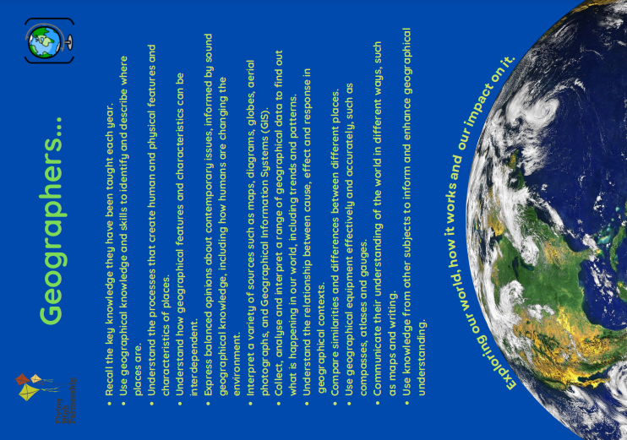

Appendix B
FHT Curriculum Structure Flowchart: How our model is enacted
Before planning the curriculum intent, each school designs key principles that underpin the curriculum. These are the most important things that children need to thrive and succeed. The principles are derived from the school’s context.
Principles

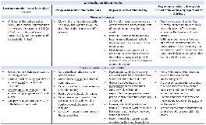
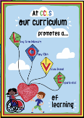
The FHT curriculum meets and sometimes exceeds the expectations of the NC, EY educational programmes and other documentation, such as the RE agreed syllabus. National association materials have been used to enhance the curriculum and ensure expertise is evident in our design.
Statutory
docs

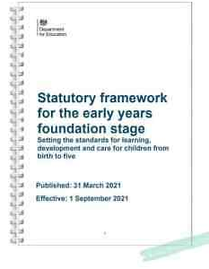
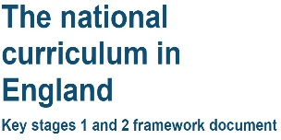

Statements from each subject within the statutory documentation have been broken down and sequenced into strands and year groups. We call these key knowledge progression documents (KKPDs). These contain key substantive, procedural and disciplinary knowledge across all subjects, including PSHE/RSE. Each KKPD sets out the end points for each year group. These are derived from the subject’s end point poster (what children need to know and do to be secondary-ready). KKPDs start in Nursery and continue into Year 7.

KKPDS – Composite knowledge

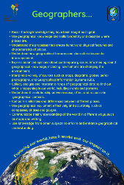
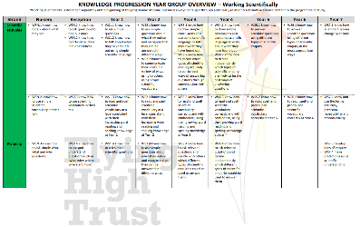

Composite knowledge from the KKPDs is mapped on to a whole school long-term plan and sequenced on subject maps. This work is completed by subject leaders, alongside the teaching team. The curriculum lead oversees all work to ensure a sequential and progressive curriculum. They ensure links are made across year groups and subjects through deliberate and diverse content choices.
Each subject has a subject map that shows what knowledge pupils will learn and in which term of each year group, with knowledge building over time.
The rationale for content choices is given to indicate how learning links to previous and subsequent study within the subject and across other subjects. The
Whole school long-term plan sets out what pupils in each year group will be taught in all subjects through a termly enquiry or discrete teaching. Subjects are delivered as drivers and enhancers to the enquiry (when this enables children to answer the enquiry question to its fullest.) When this is not possible the subject is taught discretely. See enquiry on a page document.

Subject maps and
Long-term plan
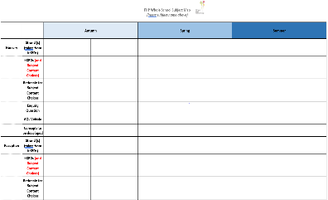

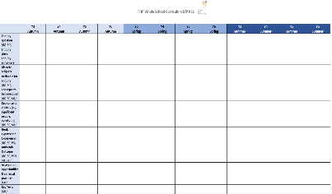

Each KKPD statement is broken down into component (granular) knowledge and key vocabulary. Each subject has a component knowledge progression document (CKPD). Schools tailor these to match the content choices made in subject maps. These progressions are used to support the creation of learning sequences and to identify ‘sticky knowledge’ – the most important knowledge children need to remember for the next stage. These documents have been created and quality-assured by leading subject experts from the trust and world of education.

Component knowledge progressions

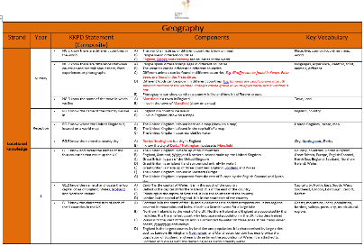

KKPDs and CKPDs are used by teachers to create learning sequences and objectives. These are plotted on an enquiry and a discrete medium-term plan. Sticky knowledge we want children to know and remember is clearly identified, alongside ambitious, tier 3 vocabulary. This decision is checked by the subject leader, as the expert of the curriculum progression in school. This sticky knowledge/vocabulary is included on knowledge organisers. Opportunities for promoting British Values, SMSC, working with experts and the community, and leaving a legacy are identified at this stage.

Medium-term
plans
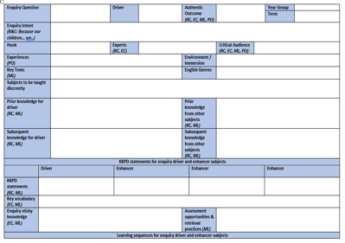

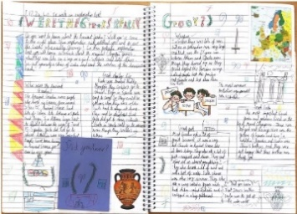
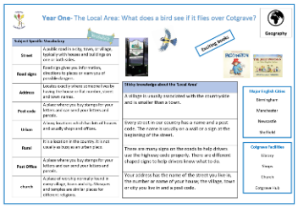
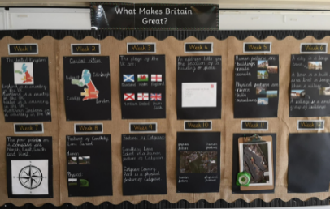
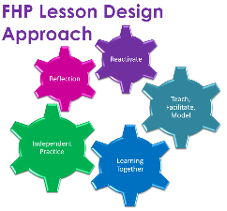
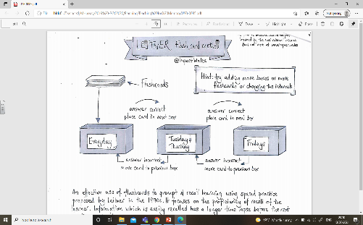
Lessons and recording
Individual lessons are then planned in finer detail using the lesson design model. At this stage, learning will be adapted for pupils with SEND, using the QFT and subject-specific SEND adaptation sheets. These ensure teachers provide access to lesson content with no lowering of ambition for these pupils. Learning is ideally evidenced in the children’s enquiry books. Curriculum symbols are used on each piece of work to indicate the subject that children are studying and the subject-specific knowledge and skills they will need to apply. Knowledge organisers, including key vocabulary, are created for children to refer to throughout the enquiry.

A ‘learning journey’ display is built up throughout the enquiry. Included on the learning journey will be sticky knowledge and key vocabulary.
Sticky knowledge is checked using a variety of assessment tools, including the Leitner model, double page spreads, knowledge organisers, Plickers and the ‘reactivation’ stage of the lesson design.

Learning journey & assessment
At the end of each enquiry, children answer the enquiry question and showcase an authentic outcome, demonstrating the knowledge they have gained.

